Please return by ____(date)_____
Parent Survey About Walking and Biking to School

Dear parent/guardian,
In an effort to promote children’s daily physical activity and reduce traffic around the school, we’d like to encourage regular walking and biking to/from school this year. Please complete the survey below (ONE PER FAMILY) and return it to the school by _(day), __(date)__. Your answers will be used to provide your children with safe, convenient, and fun opportunities to walk, bike, explore, and learn this school year! Thank you for your time and interest!

1. How many of your children attend ___(school name)__? _____ Grade(s): ____________
2. How far does your child live from school?
􀂅 Less than ¼ mile 􀂅 ½ mile to 1 mile 􀂅 More than 2 miles
􀂅 ¼ to ½ mile 􀂅 1 mile to 2 miles 􀂅 Don’t know

3. On most days, how does your child arrive and leave for school?
Arrive at school
􀂅 Walk 􀂅 Bike 􀂅 School Bus 􀂅 Family Vehicle 􀂅 Carpool 􀂅 Transit 􀂅 Other

Leave from school
􀂅 Walk 􀂅 Bike 􀂅 School Bus 􀂅 Family Vehicle 􀂅 Carpool 􀂅 Transit 􀂅 Other

4. If you regularly drive your child(ren) to/from school, please check all the reasons for that choice:
􀂅 N/A – My child walks, bikes, or buses 􀂅 Speed of traffic along walking/biking route
􀂅 Drop off on way to work 􀂅 Lack of sidewalks/pathways 􀂅 Running late / avoid tardiness 􀂅 Condition of sidewalks/pathways
􀂅 Bad weather (rainy/too hot) 􀂅 Dangerous crossings
􀂅 Lack of adults to walk or bike with 􀂅 Lack of crossing guards
􀂅 Distance is too far 􀂅 Stranger danger concerns
􀂅 Child(ren) too young 􀂅 Crime
􀂅 Too much traffic along walking/biking route 􀂅 Other ______________________

5. Has your child(ren) asked for permission to walk or bike to/from school in the last year? 􀂅 Yes 􀂅 No

6. How much fun is walking or biking to/from school for your child(ren)? (select one)
􀂅 Very Fun 􀂅 Fun 􀂅 Neutral 􀂅 Boring 􀂅 Very Boring 􀂅 N/A

7. Do you have specific concerns along your walking/biking route to school? (i.e. poor sidewalks; lack of
connections, intersection issues, dogs, other hazards). Please describe and give location.
_______________________________________________________________________________
_______________________________________________________________________________

Over for second page
8. Would you like your child to participate in regular walking/biking programs offered by the school?
If so, which of the following activities interest you the most:
􀂅 N/A – I’m not interested 􀂅 Pedestrian safety education
􀂅 Bike rodeo (riding skills education) 􀂅 Monthly/weekly active travel challenge(s) 􀂅 Bike repair 􀂅 Afterschool bike club
􀂅 Walking School Bus* 􀂅 Weekend bike rides
􀂅 Bicycle Train* 􀂅 Other: _______________________
* A Walking School Bus and Bicycle Train function like a regular bus, with a defined route and specific schedule. Children and an adult leader walk or bike to school together one or more days per week.

9. Please provide any additional comments below.
_______________________________________________________________________________
_______________________________________________________________________________

A prize will be given to all students who return their survey by
__(day), __(date)__.
If you have more than one child at the school, simply write “FAMILY DUPLICATE” on the top of the
form(s) you do not complete. These will also be eligible for a prize. Thank you for your time and input!

We’ll keep you in the loop!
If you’d like to be informed of upcoming walk/bike activities at the school (bike repairs, family rides, walking school bus opportunities, etc.), please provide your contact info below.

Yes, I want to be informed about walking/biking opportunities for my children.

Name: ___________________ Email: ______________________ Phone: _______________

If you have interest in a Walking School Bus or Bicycle Train, what is the street intersection closest to your home? _________________________ and _________________________ (2 street names)

􀂅 Check here if you’d be willing to organize and/or help lead a Walking School Bus or Bicycle Train.

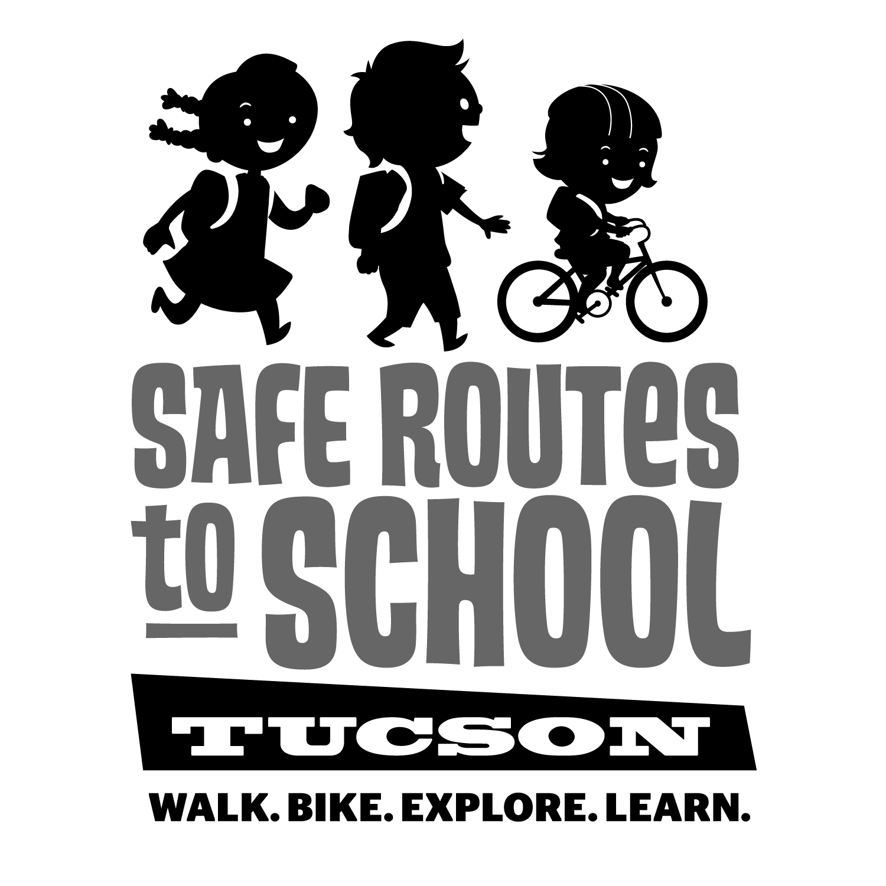
Safe Routes to School Tucson is a program of Living Streets Alliance in partnership with the City of Tucson.
Additional info, event listings, photos, and more can be found at:
www.saferoutestucson.org AND www.facebook.com/SRTSTucson

