__DATE__
Safe Routes to School Student Travel Tally
Dear teacher,
Please complete this survey on two days in the coming week. Thank you!
Instructions:
- Complete the following fields
SCHOOL:____________________
GRADE:_____________________
NUMBER OF STUDENTS ENROLLED IN CLASS: ____________________
MONDAY’S DATE: ___________________
- Ask students “How did you arrive at school today?” and “How will you go home after school?” Have students raise their hands for each travel mode and put the number of students in the box next to the appropriate response.
- Do this for two days in the week, on a Tuesday, Wednesday, and/or Thursday.
- Return to the front office by end of day on __(day)_, _(date)_.

 | Weather  S=sunny  R=rainy | Total students at time of count | Walk | Bike | School Bus * | Family Vehicle | Carpool | Transit  (city bus) | Other (scooter etc.)
Tues AM
Tues PM
Wed AM
Wed PM
Thurs AM
Thurs PM
* Daycare van transportation can be counted as school bus.
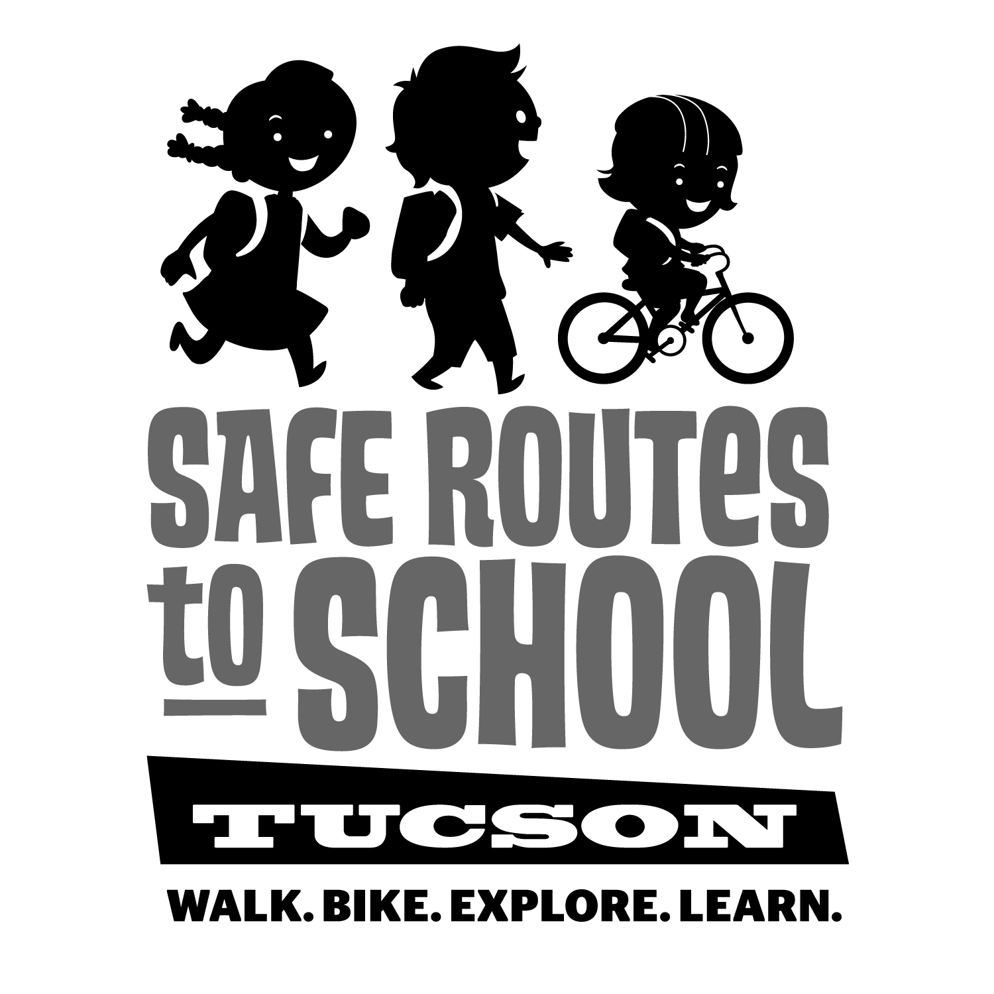

This survey is required for the program that supports Walk to School days, bicycle repair and encouragement activities, safe route mapping, and more.

Thank you for your assistance!

