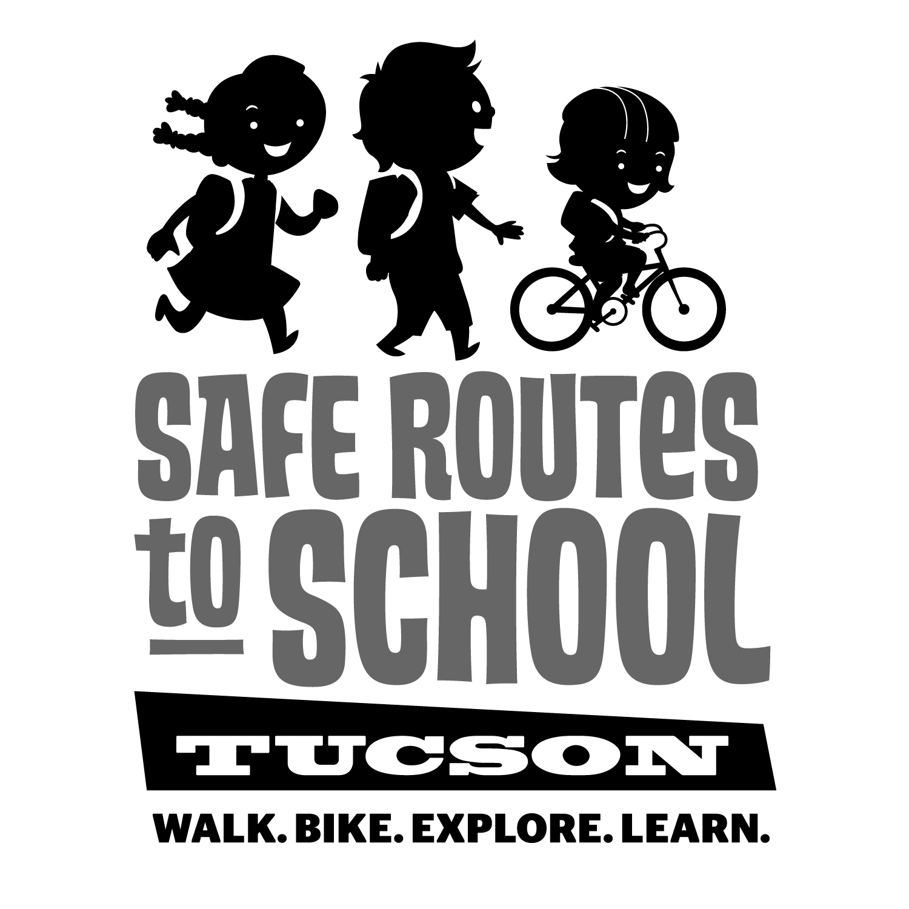

walk as a group to share the exercise and fun! Live too far from school? Kids can “make tracks” to a friend’s home, run an errand, or use their feet for other travel. Good luck!

Dear parent or guardian,

This year, our school is sponsoring the “Make Tracks Active Travel Challenge” to encourage kids to be active, stay healthy, and discover the fun and energy of traveling by foot! In addition, children who walk or bike to school concentrate better in the classroom, and walking is a great way for YOU to spend quality time connecting with your kid(s).

During each month of the challenge, your child will receive a scorecard to track their trips by circling a shoe, bike, or board each time they walk, bike, or skate/scooter. At the end of each month, participating kids who return their scorecard will receive a small prize. The class with the most active travelers will also be awarded the school’s traveling trophy!

Please encourage your child(ren) to walk, bike, or skate/ scooter to school. Use the best route and

walk as a group to share the exercise and fun! Live too far from school? Kids can “make tracks” to a friend’s home, run an errand, or use their feet for other travel. Good luck!

Dear parent or guardian,

This year, our school is sponsoring the “Make Tracks Active Travel Challenge” to encourage kids to be active, stay healthy, and discover the fun and energy of traveling by foot! In addition, children who walk or bike to school concentrate better in the classroom, and walking is a great way for YOU to spend quality time connecting with your kid(s).

During each month of the challenge, your child will receive a scorecard to track their trips by circling a shoe, bike, or board each time they walk, bike, or skate/scooter. At the end of each month, participating kids who return their scorecard will receive a small prize. The class with the most active travelers will also be awarded the school’s traveling trophy!

Please encourage your child(ren) to walk, bike, or skate/ scooter to school. Use the best route and

***[www.saferoutestucson.org](http://www.saferoutestucson.org) / [www.facebook.com/SRTSTucson](http://www.facebook.com/SRTSTucson)***

[***www.saferoutestucson.org***](http://www.saferoutestucson.org) ***/ [www.facebook.com/SRTSTucson](http://www.facebook.com/SRTSTucson)***

