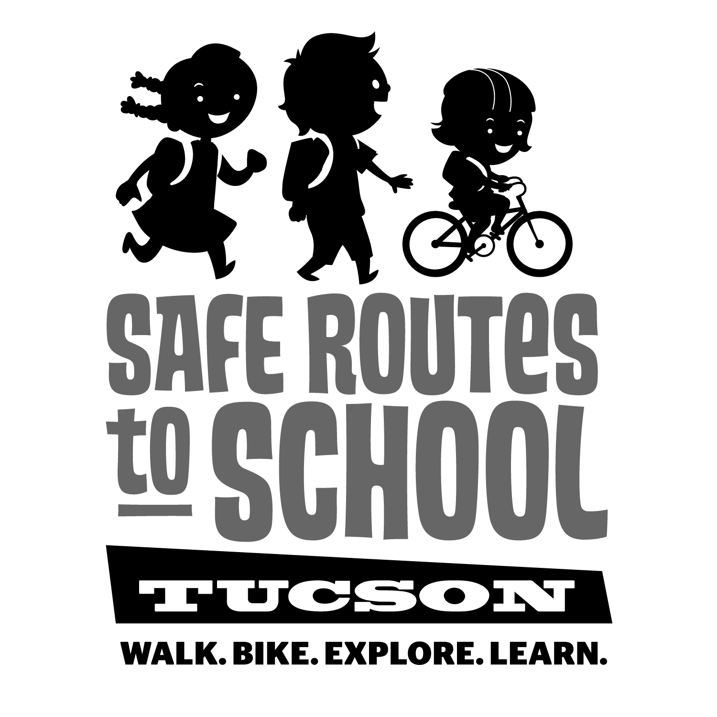

[***www.saferoutestucson.org***](http://www.saferoutestucson.org) ***/ [www.facebook.com/SRTSTucson](http://www.facebook.com/SRTSTucson)***

[***www.saferoutestucson.org***](http://www.saferoutestucson.org) ***/*** [***www.facebook.com/SRTSTucson***](http://www.facebook.com/SRTSTucson)

We invite you to put on comfortable shoes and walk to school on Wednesdays.

If you live too far from school, consider parking your car a few blocks away and walk from there. We hope you discover things along the way that make you say ***WOW!***

We invite you to put on comfortable shoes and walk to school on Wednesdays.

If you live too far from school, consider parking your car a few blocks away and walk from there. We hope you discover things along the way that make you say ***WOW!***



Dear parents & guardians,

This year, our school is beginning a new program, the ***WOW! (Walk/Wheel on Wednesdays) Challenge*** to encourage students to walk, bike, learn, and explore throughout the school year!

Here’s how it works:

1. Students receive a new scorecard for each month of the challenge.
2. Each Wednesday*, kids track their trips by circling a shoe, bike, or board when they walk, bike, or skate/scooter to school.
3. Kids who complete four or more ***WOW!*** boxes per month receive a small prize.

*Missed a Wednesday? Just walk, bike, skate/scooter on another day.

Children who walk or bike to school concentrate better in the classroom, and walking is also a great way for YOU to spend quality time connecting with your kid(s).

Dear parents & guardians,

This year, our school is beginning a new program, the ***WOW! (Walk/Wheel on Wednesdays) Challenge*** to encourage students to walk, bike, learn, and explore throughout the school year!

Here’s how it works:

1. Students receive a new scorecard for each month of the challenge.
2. Each Wednesday*, kids track their trips by circling a shoe, bike, or board when they walk, bike, or skate/scooter to school.
3. Kids who complete four or more ***WOW!*** boxes per month receive a small prize.

*Missed a Wednesday? Just walk, bike, skate/scooter on another day.

Children who walk or bike to school concentrate better in the classroom, and walking is also a great way for YOU to spend quality time connecting with your kid(s).

